1. Date - print or set the system date and time

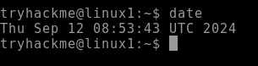

1. whoami

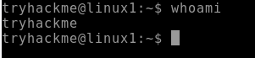

1. whatis

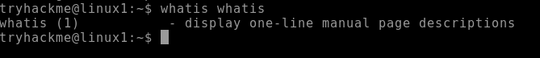

1. man

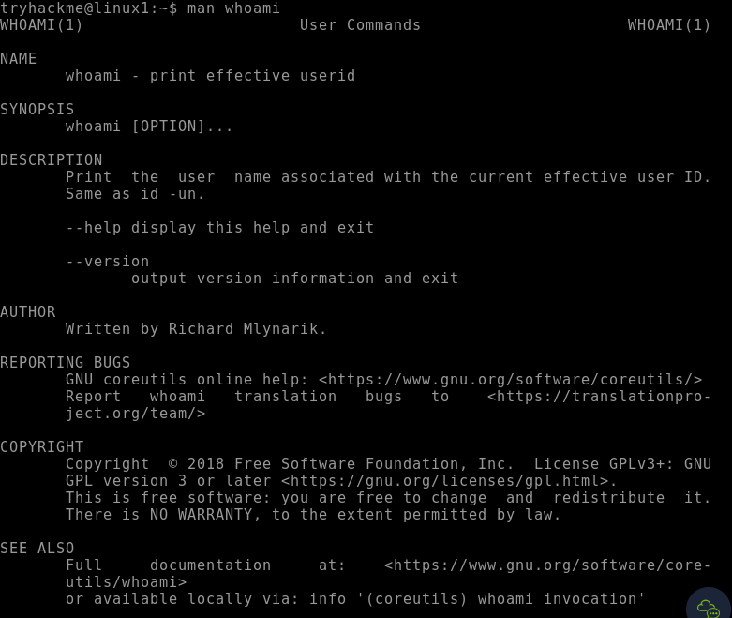

1. pwd - print working directory

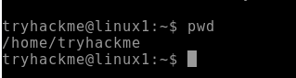

1. mkdir

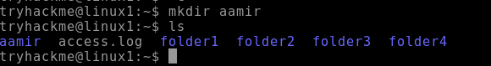

1. rmdir

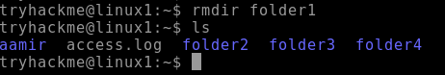

1. ls



1. ls -l

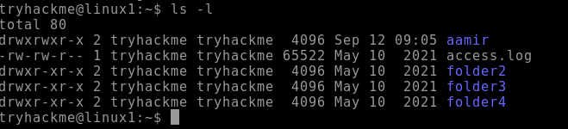

1. cd



1. cat

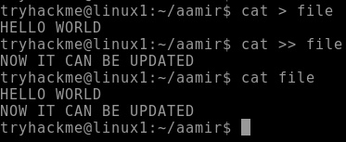

1. touch

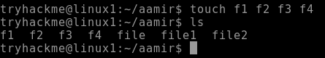

1. cd



1. cal

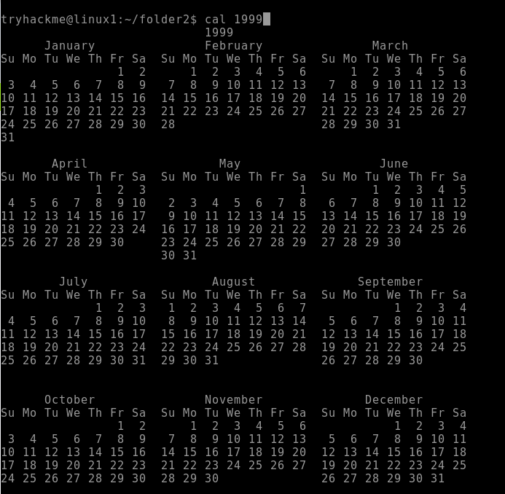

1. echo

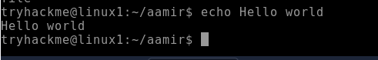

1. cp